Github link: https://github.com/Jzheng48/Module-3-Assignment-Data-Format.git

Reusable components to create a composite components:-1



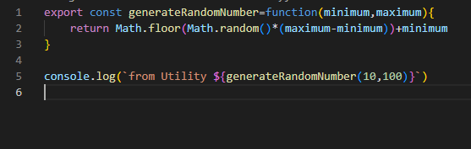



Using Importing External Modules (third-party modules).



Data Formats and Data Exchange

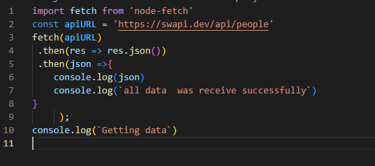

Content Negotiation

